Lab#1 Introduction to HTML [Font Cambria (Headings) size 14 bold]
(Basic HTML, Hyperlink and Commenting code) [Font Cambria size 12]

TAGS USED | ATTRIBUTES USED | DESCRIPTION
<HTML> | lang | Defines the root of the HTML document. The lang attribute specifies the language of the page.
<HEAD> | -- | Contains metadata, title, styles, and other information about the webpage that is not directly displayed.
<META> | charset, name, content | Defines metadata. charset="UTF-8" sets character encoding, while name="viewport" and content make the page responsive.
<TITLE> | -- | Defines the title displayed in the browser tab.
<STYLE> | -- | Contains CSS rules used to design and style the webpage.
<BODY> | -- | Contains the visible content of the webpage.
<DIV> | class | Defines a division/container. In this code, it is used to create the loader and individual bouncing circles.
<DIV> | class="loader" | Creates the main loader container and allows the three circles to be arranged using Flexbox.
<DIV> | -- | Creates each individual circular element of the bouncing loader.
<STYLE> | -- | Contains CSS properties such as size, color, animation, alignment, and layout.
@KEYFRAMES | -- | Defines the animation named bounce, which moves the circles vertically.

Final Outcome:

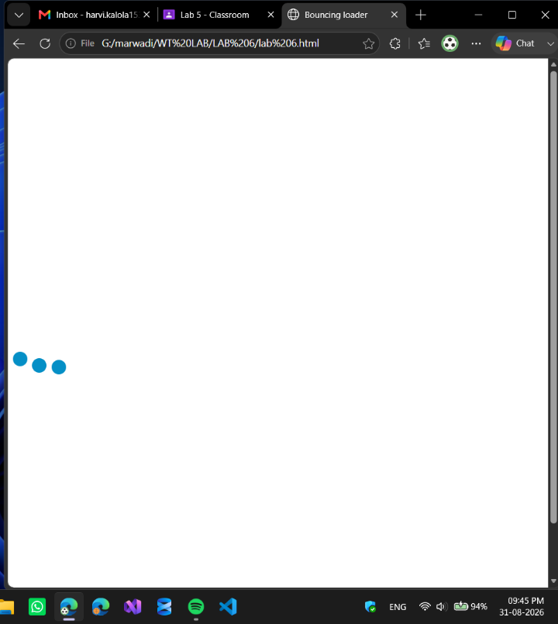

Code Snippet:
<!DOCTYPE html>
<html lang="en">
<head>
<meta charset="UTF-8">
<meta name="viewport" content="width=device-width, initial-scale=1.0">
<title>Bouncing loader</title>
<style>
.loader div {
height: 20px;
width: 20px;
background-color: rgb(4, 143, 198);
border-radius: 50%;
animation: bounce 0.6s infinite alternate;
}

.loader div:nth-child(2) {
animation-delay: 0.2s;
}
.loader div:nth-child(3) {
animation-delay: 0.4s;
}
@keyframes bounce {
to {
transform: translateY(20px);
}

}

.loader {
display: flex;
justify-content: space-between;
width: 10%;
height: 800px;
align-items: center;
}
</style>
</head>
<body>
<div class="loader">
<div></div>
<div></div>
<div></div>
</div>
</body>
</html>

